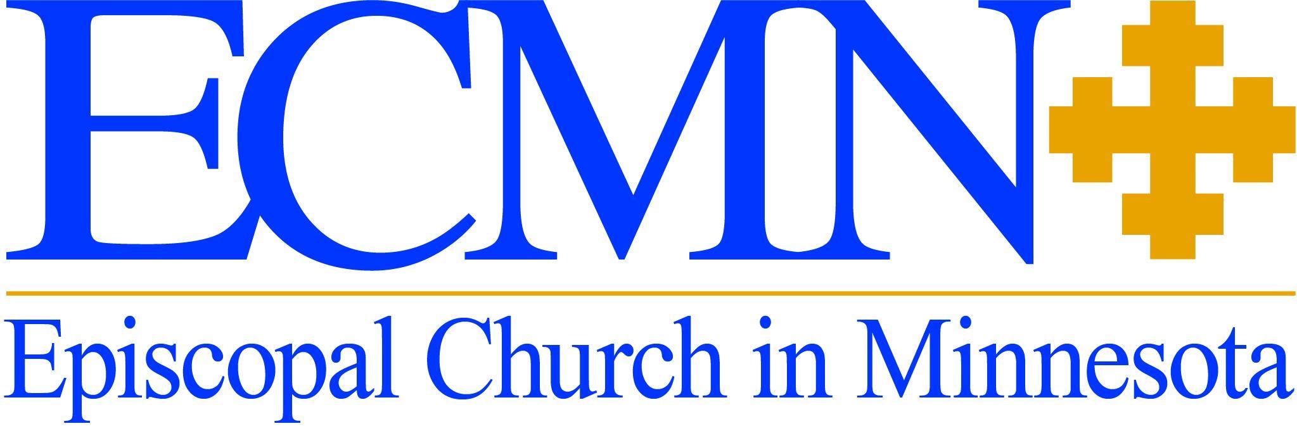

Standing Committee Roster
2024-2027

The Standing Committee is made up of 12 members—six clergy and six lay, who serve three- year terms. Members are elected by convention.

OFFICERS:
John Gappa, President
The Rev. Denise Stahura, Vice President
Tom Boe, Secretary
The Rev. Justin Chapman and the Rev. Paul Ehling, COM Liaisons
The Rev. Tom Roy and the Rev. John Spinillo-Grzywa, Joint Property Committee

Term Expires 2025

Clergy Vacancy
John Gappa
The Rev. Jon Spinillo
Minnie Steele

Term Expires 2026

Thomas Boe
The Rev. Paul Ehling
Tony Nwonye*
The Rev. Denise Stahura

Term Expires 2027

The Rev. Justin Chapman
James Huber
The Rev. Tom Roy
David Taylor

*denotes second term

