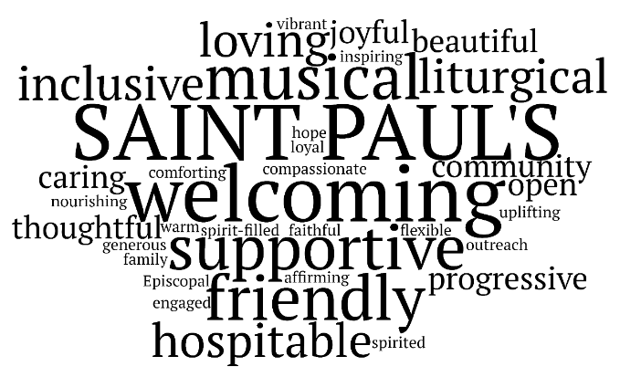

Saint Paul’s Episcopal Church, Minneapolis, Minnesota

Administrative Assistant

About Saint Paul’s:
We are a Christ-centered faith community within the Episcopal Church of Minnesota. Saint Paul’s members are deeply committed to loving God and loving our neighbor. We are diverse in membership, identity, and perspective. We celebrate our diversity as a gift from God.

Position Description:
Saint Paul’s Episcopal Church in Minneapolis is seeking an Administrative Assistant. Saint Paul’s is located at 1917 Logan Avenue South, in Minneapolis, near Lake of the Isles. The Administrative Assistant works in collaboration with the Rector. The work location is a combination of onsite and remote.

Hours: 8 hours per week. Days and hours to be determined.

Hourly Wage: $25 per hour

Annual Salary: $10,400 per year

Reports to:
The Rector of Saint Paul’s Episcopal Church, Minneapolis, Minnesota

Responsibilities:
- Manage church calendar and schedule building use
- Manage copy machine
- Order janitorial, office, and coffee hour supplies
- Manage building access
- Manage Safe Church training records
- Schedule cleaning, repair, and maintenance services with vendors
- Assist the Rector with tenant leases and building-use agreements

Required Skills and Experience:
- Working knowledge of Gmail, Gmail Docs, Word, scheduling software
- Ability to learn building access software
- Strong verbal and written communication skills
- Desire to work in a small team environment
- Background working vendors a plus
- Previous experience working in a church or non-profit a plus

Education/Experience:
- Highschool diploma and at least one year of related work experience

Additional Requirements:
- Before hiring, the candidate must be willing to undergo a criminal background check to comply with Episcopal Church Safe church requirements
- After hiring, the employee must successfully complete Episcopal Church Safe Church Training

Submit letter of interest and resume to The Reverend Ramona Scarpace at Ramona@stpaulsmpls.org by March 1, 2026.

