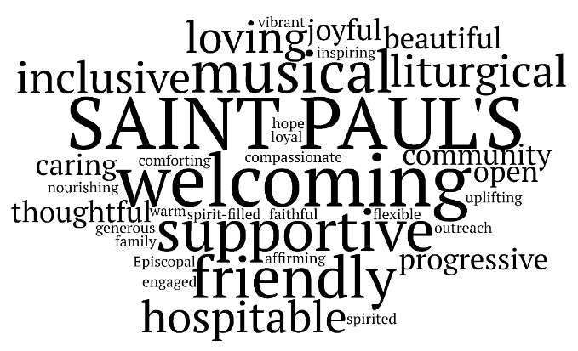

**Saint Paul’s Church on Lake of the Isles in Minneapolis, Minnesota**

**Finance and Facilities Coordinator Position**

**About Saint Paul’s:**

We are a Christ-centered faith community within the Episcopal Church in Minnesota. Saint Paul’s members are deeply committed to loving God and loving our neighbor. We are diverse in membership, identity, and perspective. We celebrate our diversity as a gift from God.

**Position Description:**

Saint Paul’s Episcopal Church on Lake of the Isles is seeking a Finance and Facilities Coordinator to join our administrative team. Saint Paul’s is located at 1917 Logan Avenue South, in Minneapolis, near Lake of the Isles. The Finance and Facilities Coordinator works in collaboration with the Rector and Vestry (church leadership), church Treasurer, and the Building and Grounds Committee. The work takes place primarily on-site at Saint Paul’s Church.

**Hours**: 30 hours per month (approximately 7.5 hours per week)

**Salary:** $1000 per month

**Reports to:**

The Rector of Saint Paul’s Episcopal Church on Lake of the Isles

**Responsibilities:**

**Finance**

* Basic bookkeeping and accounting
* Post contributions and other receipts
* Pay vendors by check or ACH
* Call in payroll to payroll provider semi-monthly
* Enter journal entries as directed by the Treasurer
* Reconcile bank accounts monthly
* Work with the Treasurer on financial data requests, reports, etc.

**Facilities**

* Scheduling of building use. Point of first contact for building use requests, including weddings, funerals, and community groups. Primary contact for building users and tenants
* Maintain Master Online Calendar
* Point of first contact for parish voicemail and email system
* Distribute mail
* Track and invoice copy machine use
* Work with vendors to schedule, supervise, and provide feedback to cleaning service and lawn maintenance teams. May coordinate vendors for special projects.
* With church leadership, help with building rentals and leases
* Ensure that all building users have up-to-date Building Use Agreements and liability waivers
* Order building, cleaning, and office supplies, and maintain inventories
* Provide event setup as needed
* Track building access via DoorBird software
* Ensure the orderliness of interior building space
* Ensure clear outdoor access for all parish events

**Required Skills and Experience:**

* Basic bookkeeping and accounting knowledge. Working knowledge of REALM (an ACS product) or similar accounting system like QuickBooks
* Working knowledge of Gmail, Gmail Docs, Word, scheduling software
* Strong verbal and written communication skills
* Desire to work in a small team environment
* Background in working with volunteers a plus
* Previous experience working with vendors a plus
* Previous experience working in a church or non-profit a plus

**Education:**

* Associate’s degree in accounting or two to three years of bookkeeping experience preferred.

**Additional Requirements:**

* Before being hired, the candidate must be willing to undergo a criminal background check.
* After being hired, the employee must successfully complete Episcopal Church Safe Church Training

**Applications are due by Friday, April 25, 2025:**

Submit letter of interest and resume to Rev. Ramona Scarpace at [Ramona@stpaulsmpls.org](mailto:Ramona@stpaulsmpls.org)